#### HANDS Dissemination

#### Cluster meeting with representatives of newly selected CBHE projects

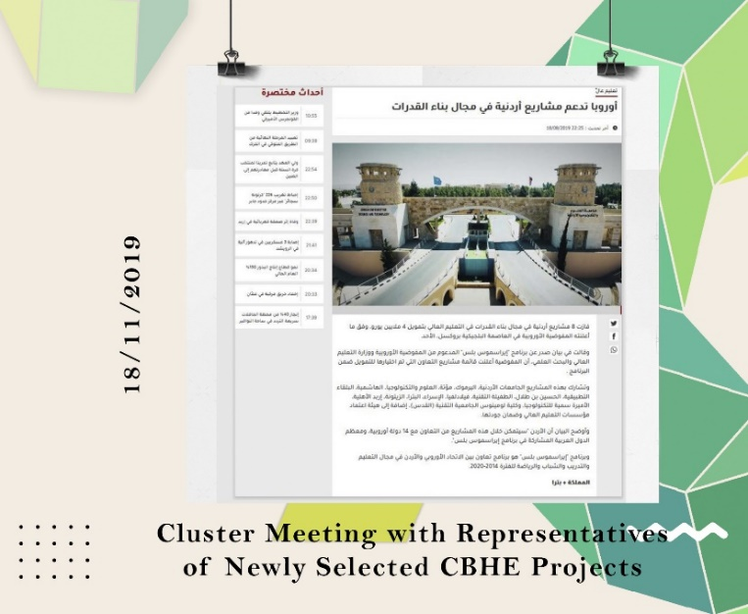**WP 8: DISSEMINATION & EXPLOITATION**

**Date:** Monday, 18/11/2019  
**Organizer:** National Erasmus+ Office / Jordan  
**Location:** Geneva Hotel, Amman

Dr. Loai Dabbour, HANDS project coordinator, participated in a meeting hosted by the National Erasmus+ Office. The event connected representatives of funded projects, fostering knowledge exchange and collaboration. Dr. Dabbour presented HANDS, highlighting its goals and potential impact. This engagement facilitated networking, best practice sharing, and valuable insights for successful project execution.